William K. Moore, III
Date Performed: 11/30/06
EE201-06
Final Project: Single Digit Prime Counter

1. Introduction
I was tasked to design and build a state machine that counted single digit prime numbers in sequential order. Excluded odd numbers were to move to state seven and excluded even numbers were to move to state two. The current digit was displayed on a seven-segment common-cathode display. This was facilitated by a SN7448 BCD decoder. The circuit was to be wired using only NAND gates, SN7474 D-flipflops, the SN7448 BCD decoder, seven-segment display, and the provided breadboard.
2. Theory and Analysis
By definition, the single digit primes to be included in the state machine are two, three, five, and seven. The excluded odd number is one and the excluded even numbers are zero, four, six, and eight. Since it was specified that all combinational logic was to be implemented using NAND gates, I had to use DeMorgan's theorem to convert all my logic.
3. Procedures
3.1 Logic Derivation
There were no direct procedures given for this project, because it was the final project of the EE201 lab. I created a state diagram and a state transition table. I then jumped directly to the input equations, skipping the Karnaugh maps. After deriving the input equations, I converted them to NAND-only logic using DeMorgan's theorem.
3.2 Wiring The Circuit
First, I gathered the parts required for wiring the circuit. I required two SN7400 NAND chips, one SN7410 NAND chip, two SN7474 D-flipflop chips, one SN7448 BCD decoder chip, and one seven-segment display. Next, I placed the NAND chips on the breadboard and wired them together according to the attached design. Afterward, I placed the D-flipflop chips on the breadboard and connected them to the NAND gates. Then, I placed both the seven-segment display and the SN7448 BCD decoder chip on the breadboard and wired them to the D-flipflop chips and to each other. The last part of this gave me some issues. It took some instruction and a rewiring of that part of the breadboard to get it to work properly.
4. Results
What follows is the state diagram that I drew. It has been converted to electronic format for readability. Also below is the state transition table that resulted from the diagram and the associated input formulas. The wiring diagram and simulation are attached.
State Transition Table
A | B | C | A(t+1) | B(t+1) | C(t+1)
0 | 0 | 0 | 0 | 1 | 0
0 | 0 | 1 | 1 | 1 | 1
0 | 1 | 0 | 0 | 1 | 1
0 | 1 | 1 | 1 | 0 | 1
1 | 0 | 0 | 0 | 1 | 0
1 | 0 | 1 | 1 | 1 | 1
1 | 1 | 0 | 0 | 1 | 0
1 | 1 | 1 | 0 | 1 | 0

State Diagram
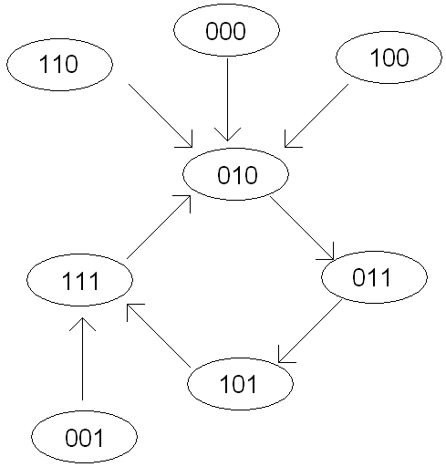
5. Discussion and Conclusion
The final wiring worked as expected, but in retrospect, the issue that caused me to rewire half of the circuit was most likely a faulty lane on the breadboard. Once I moved the BCD and seven-segment display section of the circuit to a different part of the breadboard, the malfunction disappeared and the circuit functioned flawlessly. Although the workings behind the circuit were somewhat simple, this was an effective test of the knowledge I gained while participating in the EE201 lab class.

